**Chapter 9 Homework**

1. The force on a particle of mass m is given by $\overset{⃑}{F}=22\hat{i}-15t^{3}\hat{j}$ (where F is in N and t is in sec). What will be the change in the particle’s momentum between t = 2 sec and t = 5 sec?

2. A 9.5 g bullet is fired into a 5.4 kg block of wood in a ballistic pendulum apparatus. The block/bullet combination after the collision swings upward a vertical distance of 6.3 cm, before the pendulum comes momentarily to rest. What is the speed of the bullet?

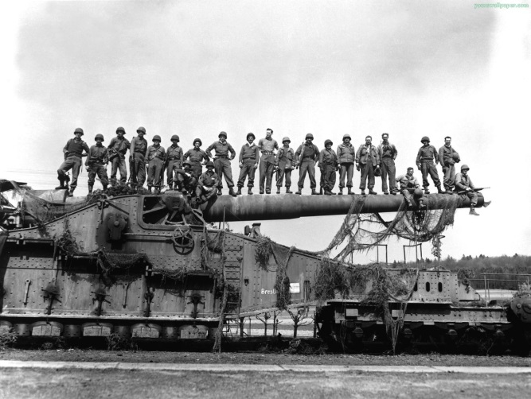3. The largest railway gun ever built was called Gustav and was used briefly in WWII. The gun, mount, and train car had a total mass of 1.22 x 106 kg. The gun fired a projectile that was 80 cm in diameter and had a mass of 7502 kg. The gun barrel is elevated to 20O above the horizontal. If the gun was at rest before firing and moved to the left at a speed of 4.68 m/sec immediately after firing, what was the speed of the projectile as it left the barrel?

4. A man claims that he can hold onto a 12 kg child in a head-on collision as long as he has his seat belt on. Consider this man in a collision in which he is in one of two identical cars each traveling toward the other at 60 mi/hr relative to the ground. The car in which he rides is brought to rest in 0.10 sec. Find the magnitude of the average force (in N) needed to hold onto the child. Is the man’s claim valid?

5. Two bumper cars moving on a frictionless surface collide elastically. The first bumper car (mass 188 kg) is moving to the right with a speed of 20.4 m/sec and hits a second bumper car (mass 143 kg), moving to the left with a speed of 9 m/sec. What is the velocity (magnitude and direction) of the first bumper car after the collision?

6. A hockey puck with mass 0.17 kg traveling along the blue line (a blue-colored straight line on the ice in a hockey rink) at 1.5 m/sec strikes a stationary puck with the same mass. The first puck exits the collision in a direction that is 30o away from the blue line at a speed of 0.75 m/sec. What is the direction and magnitude of the velocity of the second puck after the collision? Is this an elastic collision?

7. A 970 kg sports car collides into the rear end of a 2500 kg SUV stopped at a red light. The bumpers lock, the brakes are locked, and the two cars skid forward 3 m before stopping. The police officer, estimating the coefficient of kinetic friction between tires and road to be 0.8, calculates the speed of the sports car at impact. What was that speed?

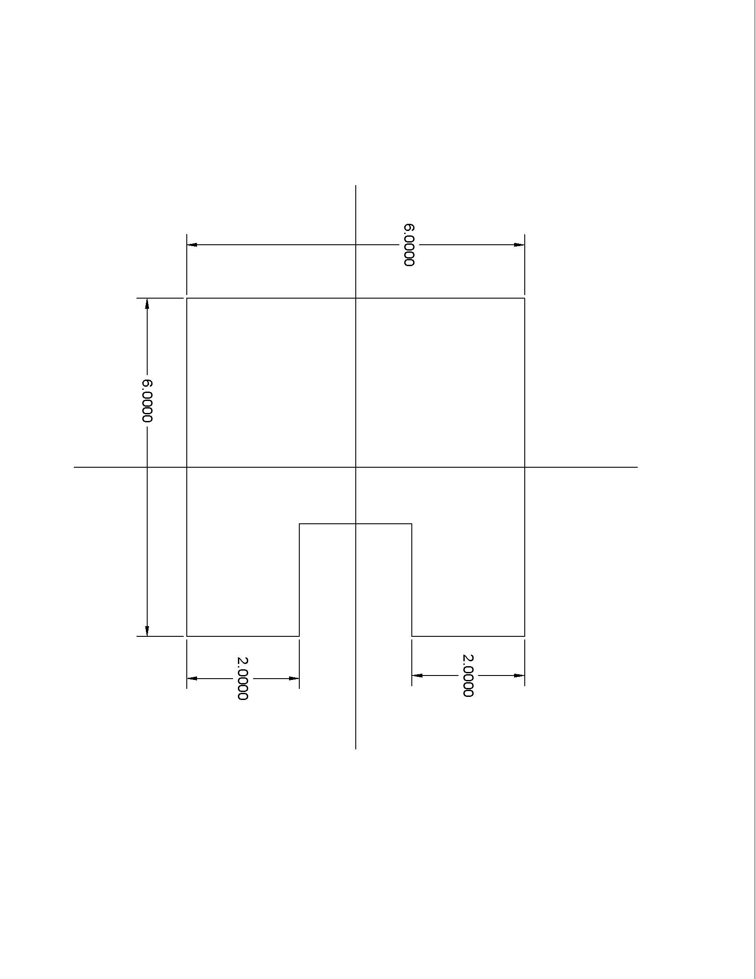8. A uniform sqare plate 6 m on a side has a sqare piece 2 m on a side cut out of it. The center of this notch is at x =2, y = 0. The center of the square plate is at x = y = 0. Find the x and y coordinates of the center of mass of the remaining piece.

9. Where is the center of mass of a system of the following three particles: mass 1 = 3 kg at origin, mass 2 = 8 kg at (1,2), mass 3 = 4 kg at (2, 1). Positions are measured in meters.